Indexing monitoring document

* Steps to monitor the Full indexing in pre prod

1. Go to path logs/emdi3/sharding in appserver(calais1).
2. Tail the latest logs to monitor the full indexing.
3. We can grep for unrecoverable in logs frequently to check the errors.

Ex: grep "unrecoverable" wc-dataimport-parallel-processor.log.0

1. If any error occurred during indexing we can check the logs in the respective search server.

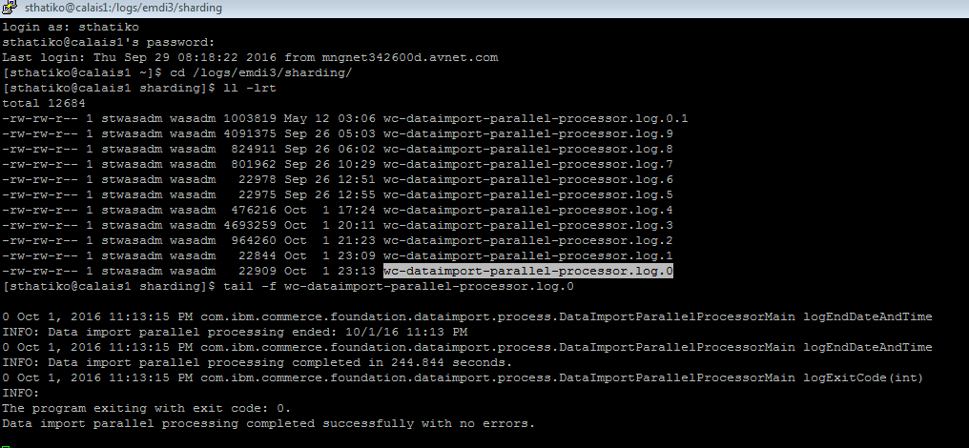

* Steps to monitor the delta indexing in pre prod

1. Go to path logs/emdi3/conventional_preprocess, logs/emdi3/conventional_buildindex
2. Tail the latest logs to monitor delta indexing.

* Steps to monitor the indexprop in pre prod

1. Go to path logs/emdi3/indexprop
2. Tail the latest logs to monitor indexprop.

Below is the sample rest call to verify all slave servers are in sync or not.

<http://cardiff1:23000/solr/MC_10001_CatalogEntry_en_US/replication?command=indexversion>

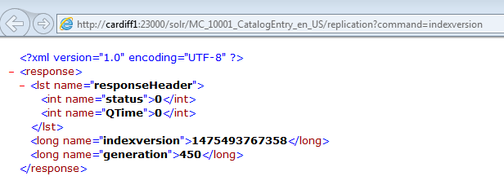

<http://corvette1:24060/solr/MC_10001_CatalogEntry_en_US/replication?command=indexversion>

